**Computer assignment #2**

Alda Magnúsdóttir Jacobsen

Hildur Mist Pálmarsdóttir

Tinna Brá Sigurðardóttir

Þórdís Gísladóttir

**Question 1**

a) Item 10 is the hardest and item 5 is the easiest one.

Discrimination Difficulty Guessing

Item 1 1 -1.40938612 0

Item 2 1 -0.35055656 0

Item 3 1 -0.90318970 0

Item 4 1 -0.97412011 0

**Item 5 1 -1.62671110 0**

Item 6 1 0.02533657 0

Item 7 1 -0.41418545 0

Item 8 1 -0.87993298 0

Item 9 1 -0.91498121 0

**Item 10 1 0.52959427 0**

Item 11 1 -1.17125435 0

Item 12 1 -0.04749604 0

Item 13 1 0.15008663 0

Item 14 1 -0.74253017 0

Item 15 1 -0.74245332 0

Item 16 1 0.36963876 0

Item 17 1 -0.84513136 0

Item 18 1 -1.45145349 0

b) -1,62671110 +1,96*0.1320051 = -1,367981104

-1,62671110 - 1,96*0.1320051 = -1,885441096

The 95% confidence interval defines a range of values that you can be 95% certain contains the true item difficulty. In this case it lies between -1,367981104 and -1,885441096.

Discrimination SE Difficulty SE Guessing SE

Item 1 NA 0.1267448 0

Item 2 NA 0.1128011 0

Item 3 NA 0.1178581 0

Item 4 NA 0.1188426 0

**Item 5 NA 0.1320051 0**

Item 6 NA 0.1118476 0

Item 7 NA 0.1131572 0

Item 8 NA 0.1175527 0

Item 9 NA 0.1180162 0

Item 10 NA 0.1136598 0

Item 11 NA 0.1220123 0

Item 12 NA 0.1118797 0

Item 13 NA 0.1119630 0

Item 14 NA 0.1159197 0

Item 15 NA 0.1159189 0

Item 16 NA 0.1126941 0

Item 17 NA 0.1171115 0

Item 18 NA 0.1276902 0

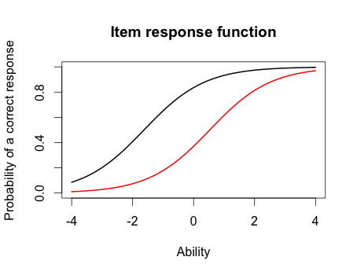c) The black line indicates the easier item and the red one is the hardest item. Ability estimate for the black line (item 5) is approximately -1.8. The ability estimate for the red line (item 10) is approximately 0.8

d) The probabiltity of correct response for the black line (item 5) would approximately be 0.9 for someone with the ability score of 0. The probability of correct response for the red line (item 10) would approximately be 0.38 for someone with the ability score of 0.

e) The score of the person who did the best is 3.999921

The score of the person who did the worst is -3.999947

> min(est_abl$est) # Prints the minimum score

[1] -3.999947

> max(est_abl$est) # Prints the maximum scores

[1] 3.999921

f) 3,999921 + 1,96*2,204373 = 8,32049208

3, 999921 – 1,96*2,204373 = -0.32065008

The 95% confidence interval defines a range of values that you can be 95% certain contains the true ability score. In this case it lies between -0.32065008 and 8,32049208.

est sem n

49 3.999921 2.204373 18

**Question 2**

1. 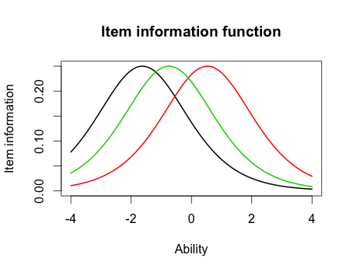We selected items 5, 10 and 15

c) The curves are the same but they are located in different places.

d) 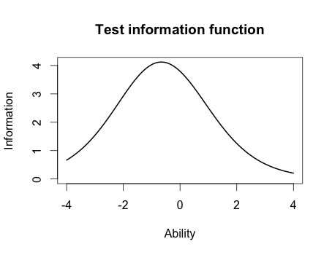

e) The most information is located in the range from 0 – (-1).

**Question 3**

1. Highest discrimination is item 8 with 2.2881772. Lowest discrimination is item 12 with 0.3329130.

Discrimination Difficulty Guessing

Item 1 0.6326689 -2.00058101 0

Item 2 1.5469622 -0.26815483 0

Item 3 1.2534918 -0.77297206 0

Item 4 0.9842598 -0.97706755 0

Item 5 1.6407242 -1.19389580 0

Item 6 1.4702029 0.01833431 0

Item 7 0.5632837 -0.65124651 0

**Item 8 2.2881772 -0.56753253 0**

Item 9 1.8004066 -0.64761748 0

Item 10 1.1142107 0.48542889 0

Item 11 1.0344119 -1.13363005 0

**Item 12 0.3329130 -0.12951933 0**

Item 13 0.3369968 0.36344671 0

Item 14 0.6608229 -1.01479867 0

Item 15 1.5980393 -0.55640285 0

Item 16 1.0362116 0.35459121 0

Item 17 1.8591845 -0.59017915 0

Item 18 1.2808752 -1.22177042 0

1. No in Rasch model it was item 5 and 10. However in the 2-PL item 10 was also the hardest but the easiest item was a different item than in the Rasch model, it was item 1.

Discrimination Difficulty Guessing

**Item 1 0.6326689 -2.00058101 0**

Item 2 1.5469622 -0.26815483 0

Item 3 1.2534918 -0.77297206 0

Item 4 0.9842598 -0.97706755 0

Item 5 1.6407242 -1.19389580 0

Item 6 1.4702029 0.01833431 0

Item 7 0.5632837 -0.65124651 0

Item 8 2.2881772 -0.56753253 0

Item 9 1.8004066 -0.64761748 0

**Item 10 1.1142107 0.48542889 0**

Item 11 1.0344119 -1.13363005 0

Item 12 0.3329130 -0.12951933 0

Item 13 0.3369968 0.36344671 0

Item 14 0.6608229 -1.01479867 0

Item 15 1.5980393 -0.55640285 0

Item 16 1.0362116 0.35459121 0

Item 17 1.8591845 -0.59017915 0

Item 18 1.2808752 -1.22177042 0

1. The correlation between the Rasch model and 2-PL is 0.9709497. This is a very large correlation. Because the correlation between these models is so large and close to 1, you could draw the same conclusions for both models. They are practically the same. If you get a high score on one test, you would also get a high score on the other one.

> cor(twopl_abl$est,est_abl$est)

[1] 0.9709497

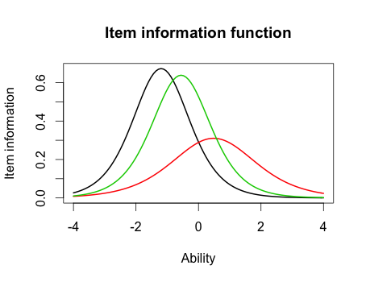

1. **2 pl model:** The black line has the most information at the item location because of the steepness. The red line has the lowest information because it is wide. The black line has the highest discrimination, the green line has a bit less and the red one has the lowest discrimination. The black line is the easiest question because it is located furthest to the left and in the (-) categorie. The green line is a little more difficult question than the black line and the red one would be the most difficult question because it is located furthest to the right and in the (+) categorie.

**2 pl model vs Rasch model:** In the Rasch model, the curves are all the same but the only difference there is that they are in a different location. In the 2 pl model, the curves are all different and they also are in a different location. They do have the difficulty of the questions the same because in both models, the black on is the easiest question, then the green and finally the red one with the hardest question. The questions in the Rasch model all have high discrimination but it varies in the 2 pl model.

